Inside-out:Develop a system then add interface. Outside-in design:Design the interface, then build the system to support it.Q1:HTTP is one of the most commonly used protocol for data communication on the www(T).The http stateless property means that a request-response cycle is dependent on the previous request-response cycle. (False)SEO.1)LinguisticSEO: Speak user langague. Architectureal SEO: link to main page as often as you can: Reputation:link from other high reputation sites are better.HTML=disable fields by writing disabled or readonly in <> tag.Block = Appear on a new line. Inline = Appear on the same line. Q2:Modal dialog boxes must be explicitly dismissed by the user. User’s mental model must be specific, informative, and positive. Q4:Step to make responsive w/o Bootstrap.1)Create page content 2)Set the viewport to ensure proper rendering and touch zooming 3)Define css rules to layout the content 4) update the html such that appropriate css rules are applied to the HTML elements5)add css 6)use @media to adjust the format/style based on the screen size. JS:Doesn’t need to get complied.JS can monitor user events and take action (server can’t) JS can do dynamic effects. Both client and JS:build dynamically. Interactive webpages. Communicate with the server asynchronously (Ajax). Drawbacks of JS: Platform dependent. Can be turned off, Performance, Security, Hard to write reliable and maintainable JS uses loose typin which means that it figures out the type based on the value.Object-based language json objects.Advantagevsdis: JS can modify html on the lient. Easy. Dis: weak typing. Poor development tools. Many scaling problems. BOM:collection of objects that the browser makes available to us for use with js.DOM objects:2purpose1)Making a model of the HTML page2)Accessing and chanign the HTML page. NOT html&js Dom is like the things for document.write()/title()Events:occur when user interacts with a. web browser. Binding specific event that can happen and on which element the event happens. When an event occurs on anelement, it can trigger a JS function. Session: a series of related interactions between a client and a web server. Cookies: Strings stored on the client to keep track of a session. Expires after some time 3600=1hour. $_Cookie[Name] $secookie(name, value, time+3600). Set expiration time in the past to completely remove cookies.Need to always start the session by writing session_start(); XML provides a way to separate data from the format. It is simple. Organize data in one resource and formatting rules in another resource. Accessibility: save time and easy to change data Standardization. Multiplie applications use xml. Xml passes data directly between components. XML allows for self-documenting data. Xml is a markup language thus it can also provide semantic information about the text in a document. Semantic tags can improve the acc of doc queries. Is scalable. XML has no password accessAngular:framework forces MVC and makes it easy to implement MVC properly. Uses a lot less code and requires a lot less DOM manipulation than traditional methods and guides you to put the manipulations in the correct locations in apps.Angular:Three phases 1)Bootstrap phase2)HTML compilation phase 3) The runtime data binding phase.AngularStructure:Build fast and organize each part in different section. Controller serves for business logic. Some of the complicated logic need controller such as connecting to the database. Bind:{{orderModel|json}}get data from back end [] bracket is one_way_binding.This square bracket will send to backend. Two way binding is [()]. Angular_syntax:Need to give a name to the form <form #orderForm=”ngForm”><input [(ngModel)]=”thing.field”. Also after declaring the input type you can do <*ngIf=”thing.field ==’’”> {{getErrorMessage}}. getErrorMessge() in angular ts file is return this.email.hasError(‘required’) ? “You …”;ngFor = loop through structure given in ts file (can be used for tree or form declaration. <tr *ngFor=”let s of students”> <td>{{s.name}} </td> and continue to go. You need to do (click)=”senddata(orderForm.value) to submit. This is one way when clicked send it to the back and process it. Q11:The main affect of using Ajax is to improve usability. Ajax calls are made when events occur. Ajax requires the response software to be on the same server as the original document. The characteristics of Ajax is to modify only small parts of the current document. 2)How does Ajax affect security? Increase the attack surface. Increased risk of cross-site scripting attacks. PHP. Send the form data to self = <?php $_SERVER[‘PHP_SELF’] ?>” method=”post”. How to get the data?if($_SERVER[‘Request_method’]==’Post’) Check for missing information by if (!empty($_POST[“Color”]) && !empty …) {##Save as a session object by doing $_SESSION[‘color’] = $color;} else { echo Missing information”}{Session Destory:if(count($_SESSION) >0) {foreach ($_SESSION as $key=>$value){unset($_SESSION[$key]);}session_destory();} XML: simplexml_load_file() or die (“ERROR”);Can get field by doing friend[0]->name or use a foreach: foreach($xml->children() as $friends) {echo $friends->name . “, “. $friends->email . “<br>”;}CookievsSesssion:Cookies are on client side and session is on server side. Users have more control over cookies. Cookies increase security problems. Session gets disabled if server decides so. Session is disabled only if user completely log out. You can also modify cookies meanwhile you can’t modify session. CSS:.error{font-style:italic;color:#fff;} HTMLselectors: Elements (p,div), Id(intro, comment), Class, Generic(error) , Pseudo (hover). HTMLFormJSvalidation: if(document.formname.nameelement = ‘’) {Document.formname.name.focus() then document.getElementBYyId(“div id of element”).innerHTML=’____’;

JavaScript onclick Cookie Setting Example XML



 With form data do a redirect

Iterate through xml







XML establish connection



Store in session object



Connect to Db Simple Javascript



CSS Selectors

Html form submission sample answer: The form data will be submitted using an HTTP POST request to the backend component named customPlate.php, which then executes the PHP code to respond to the request.

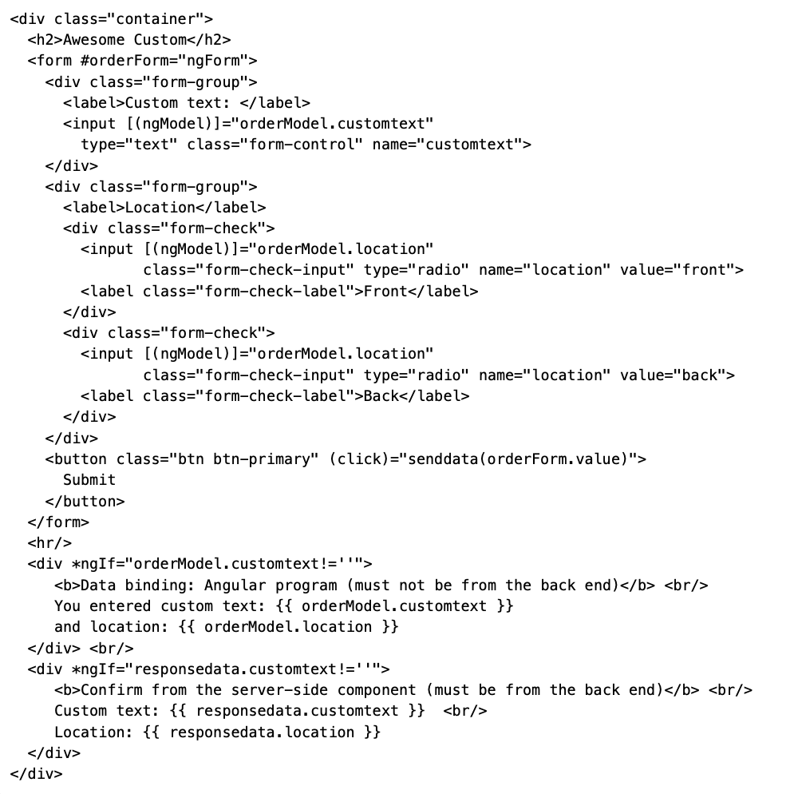Angular Solution Check for input validation and store in session

 Angular html form

Form to check validation. The value for email = placeholder



Check the field of form and re-focus if it is not filled